Assignment 8-STATISTICS AND DATA EXPLORATION

1. **mins Look at the data given below. Plot the data, find the outliers and find out Mean,Variance,Standard deviation**

Plotting the data

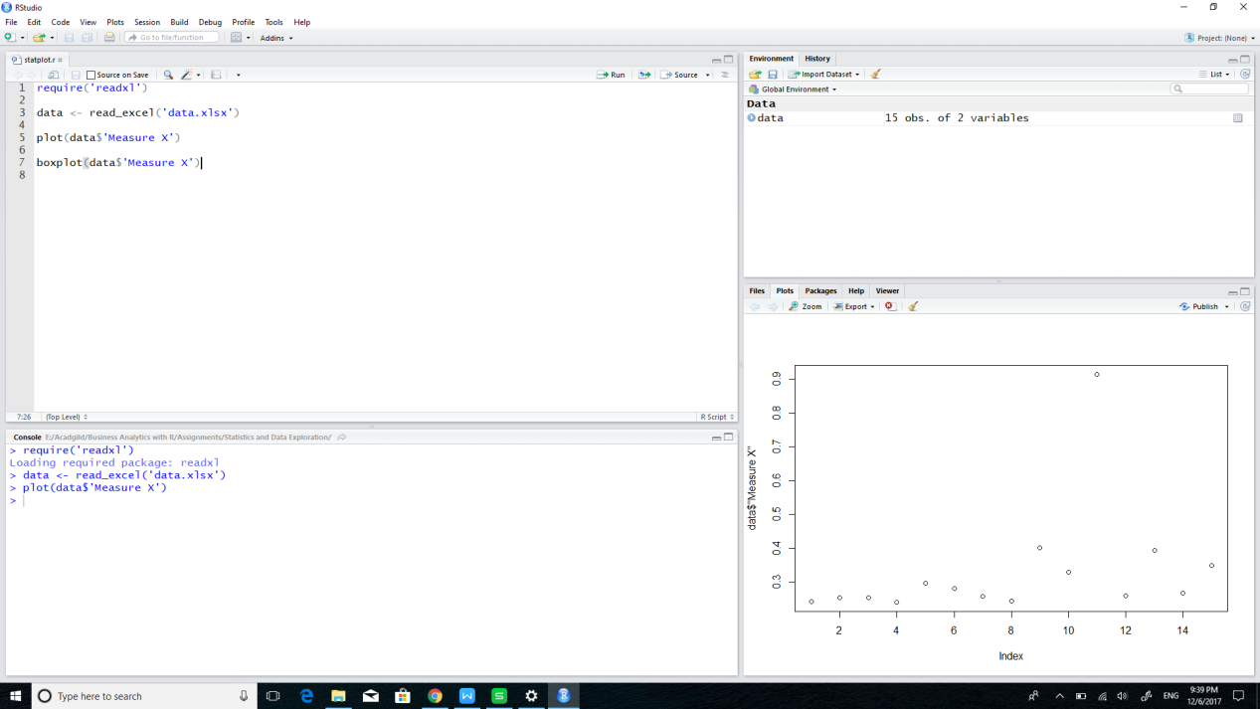

Boxplot and outlier

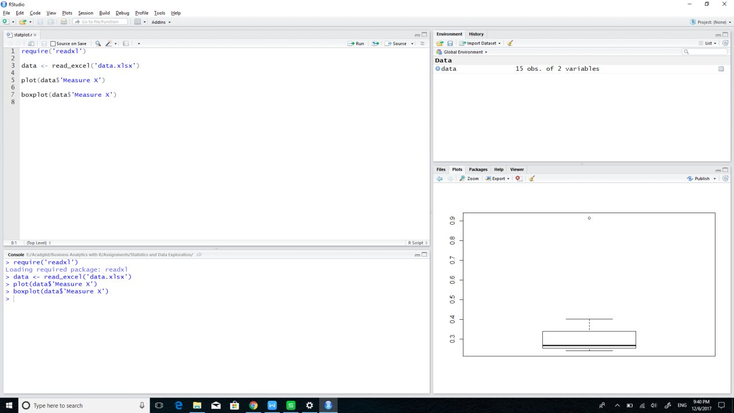

Finding variance,Standard Deviation and Mean

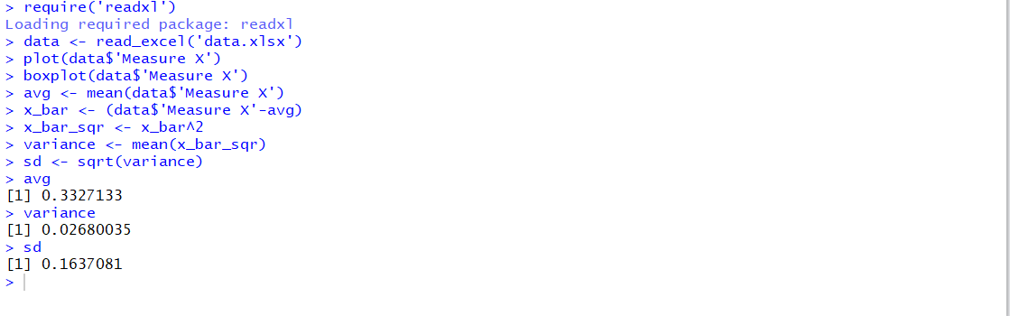

2.

a. **Interqutile range :**

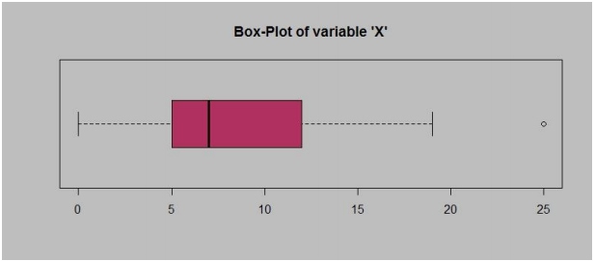

This is the range between 1st quartile and 3rd quartile

i.e 12-5 = 7

b. **Skewness of the data set :**

The dataset is skewed to the right.

c. **If it was found that the data point with the value 25 is actually 2.5, how would the new box-plot be affected?**

Median decreases and the data skewness to the right increases. As Maximum value changes to 19, no outlier is observed.

**3.**

1. **Where would the mode of this dataset lie?**

Around 5-7

B. **Comment on the skewness of the dataset.**

The dataset is right skewed.

C. **Suppose that the above histogram and the box-plot in question 2 are plotted for the same dataset. Explain how these graphs complement each other in providing information about any dataset**

Both Datasets are skewed to the right.

4. **AT&T was running commercials in 1990 aimed at luring back customers who had switched to one of the other long-distance phone service providers. One such commercial shows a businessman trying to reach Phoenix and mistakenly getting Fiji, where a half-naked native on a beach responds incomprehensibly in Polynesian. When asked about this advertisement, AT&T admitted that the portrayed incident did not actually take place but added that this was an enactment of something that “could happen.” Suppose that one in 200 long-distance telephone calls is misdirected. What is the probability that at least one in five attempted telephone calls reaches the wrong number? (Assume independence of attempts.)**

P(x=1 | 200) = 1/200 = 0.05

P(x=1| 5) = 5 * 0.05 / 200 = 0.000125

5. **Returns on a certain business venture, to the nearest $1,000, are known to follow the following probability distribution.**

* 1. **What is the most likely monetary outcome of the business venture?**
     1. 2000

b) **Is the venture likely to be successful? Explain**

The venture will be successful in the long run as the total returns in positive(800$)

c) **What is the long-term average earning of business ventures of this kind? Explain**

It’s profitable on the long run as the long-term average is 800/6 = 133.33

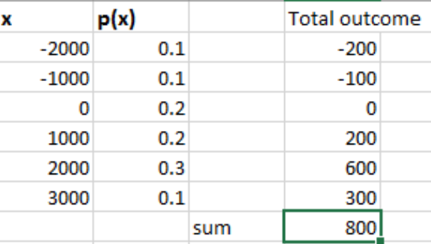

d) **What is the good measure of the risk involved in a venture of this kind? Compute this measure.**

Standard Deviation is a good measure of the risk involved in the venture.

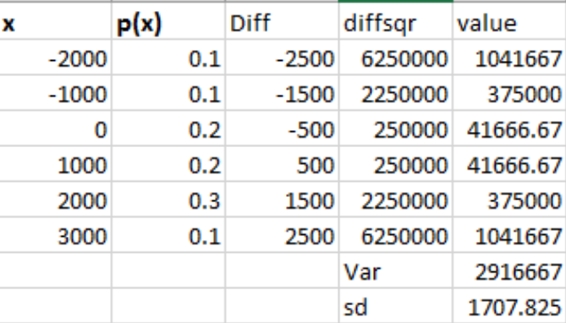

Sd = 1707.825